*  
  
  
Press Release 08/2024*

*Moers in August 2024*

# Press Release

### Efficiency in Logistics

*SB-Profi Sliding Bow Tarp System with Assembly Kit*

**Edscha Trailer Systems, a leading provider of innovative tarp systems for commercial vehicles, is introducing its revamped SB-Profi sliding bow tarp system at this year's IAA. In collaboration with partner Hofmeister and Meincke, the SB-Profi is presented for the first time with an optimized assembly kit and is now available on the market. The system impresses with outstanding running characteristics and a well-thought-out tarp concept.**

**New Features and Benefits at a Glance**

The enhanced SB-Profi sets new standards in the industry. Thanks to its flexible mounting options, the sliding bow tarp system can be installed on almost any front wall. A specially developed rain gutter ensures that no water can enter the cargo area.

Another highlight of the system is the three-part tarp concept, which allows for easier and more efficient folding of the tarp. This not only leads to faster operation but also significantly simplifies handling—a clear advantage in the fast-paced logistics environment.

**Optimized Assembly and Improved Running Characteristics**

The robust and durable rollers of the SB-Profi ensure excellent running characteristics, making the system particularly user-friendly. The modular design of the system remains intact, meaning that existing users will experience no transition issues. The proven functions and standards of the SB-Profi have been retained and thoughtfully enhanced with new features.

**Market Launch and Trade Show Presentation**

The new SB-Profi will be showcased at the IAA by Hofmeister and Meincke. The system will be presented in combination with an optimized assembly kit, specifically developed to meet the needs of the logistics industry. Interested trade show visitors are warmly invited to experience the system live and see the numerous benefits for themselves.

For more information and detailed insights, visit Hofmeister and Meincke at the IAA at Stand C09 in Hall 27 or learn more online at [www.edschats.com](http://www.edschats.com).

**About Edscha Trailer Systems**

Edscha Trailer Systems is a leading provider of sliding bow tarp systems for commercial vehicles. With decades of experience and continuous innovation, the company sets industry standards and offers solutions that meet the demands of modern logistics. The SB-Profi is a prime example of the successful combination of tradition and progress—a system that meets the needs of tomorrow, today.

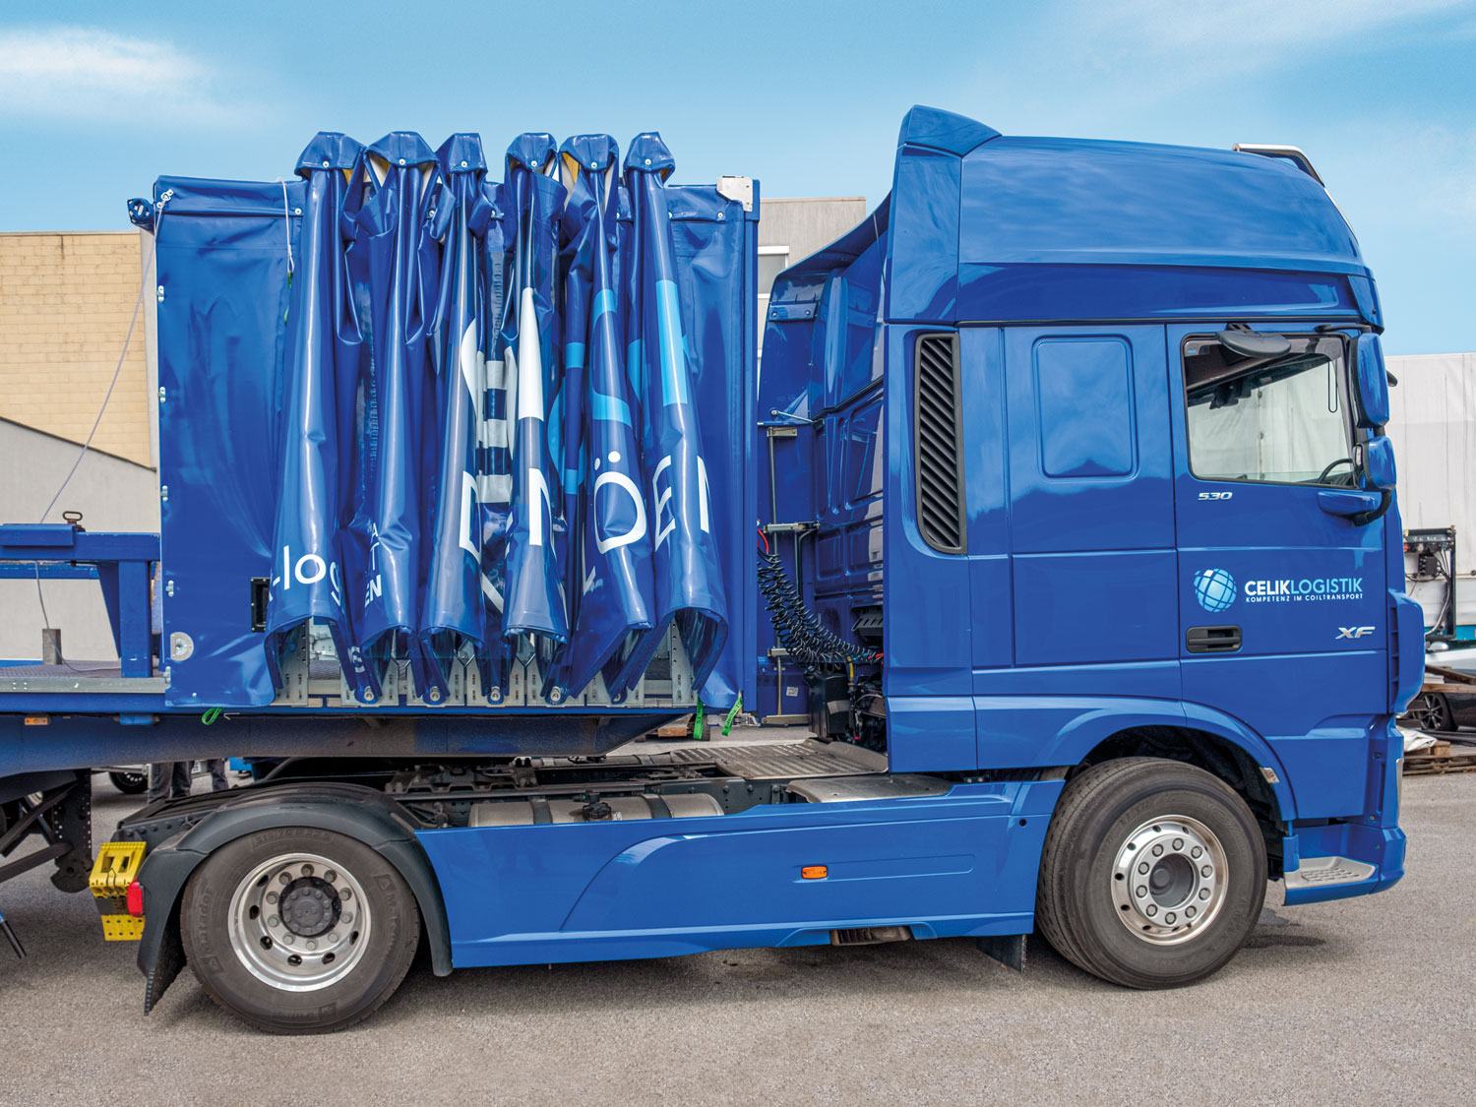 SB-Profi

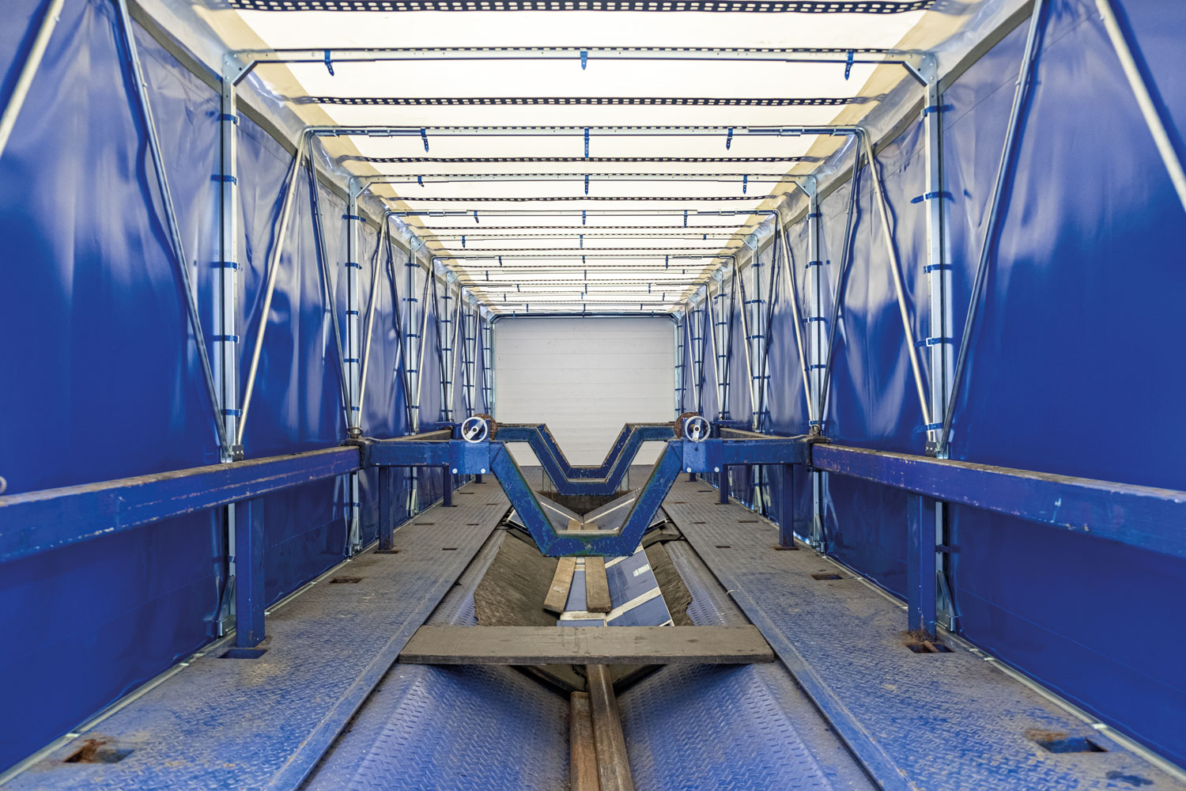 SB-Profi Innen

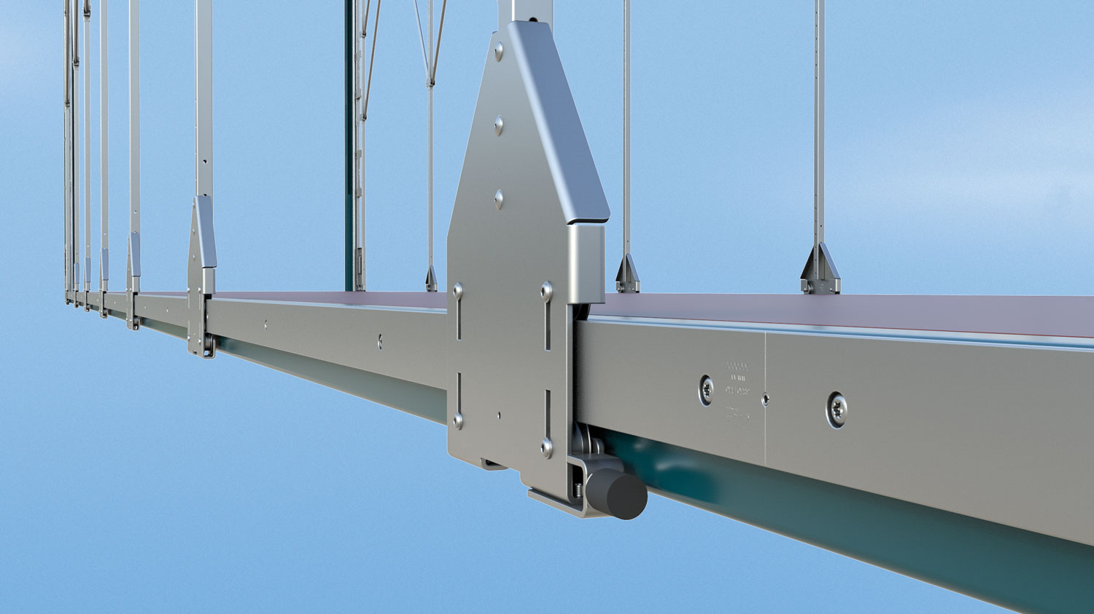 SB-Profi Rollenwagen

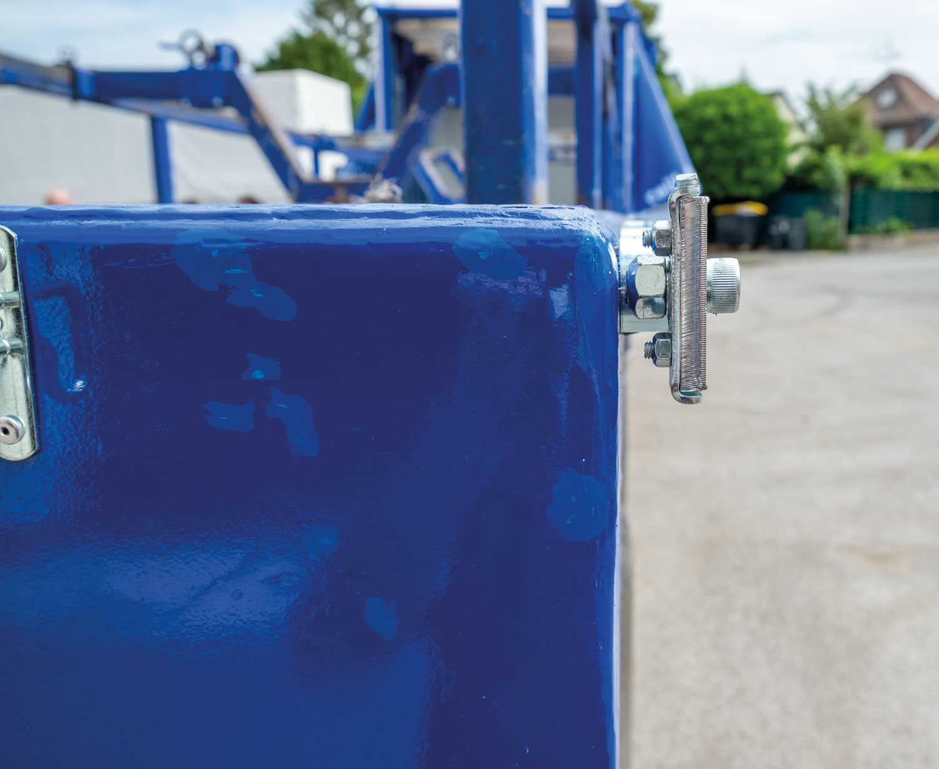 SB-Profi Schienenprofil

**Contact at Edscha Trailer Systems:**

Mr. Roger Remmel

E-Mail: [Marketing@EdschaTS.com](mailto:Marketing@EdschaTS.com)

www.EdschaTS.com Member of VBG GROUP