*  
  
  
Press Release 08/2024*

*Moers in August 2024*

# Press Release

### Big or Small

*Innovative Efficiency with QuickCurtain from Edscha Trailer Systems at IAA 2024*

**Edscha Trailer Systems is unveiling a revolutionary advancement of its QuickCurtain technology at this year's IAA Transportation in Hanover. This state-of-the-art side curtain will be showcased on both a trailer and a Fiat E-Ducato. The QuickCurtain system is designed for speed, user-friendliness, and flexibility, making it ideal for both large trailers and small distribution vehicles.**

**A Step into the Future of Logistics**

Edscha TS's QuickCurtain addresses the growing demand in the logistics industry for fast and efficient loading and unloading processes. The redesigned tarp, now made from a single continuous piece, is part of the standard offering and can optionally be customized in various colors with advertising prints and logos. Ergonomically designed grip recesses and smooth-running features make the side curtain especially easy and comfortable to operate.

**Efficiency Meets Design**

The QuickCurtain impresses not only with its functionality but also with its appealing design. The tarp provides a large, smooth surface that is perfect for advertising messages, making the QuickCurtain not just a practical tool but also a visual highlight on the road.

**Maximum Flexibility and Easy Handling**

The key feature of the QuickCurtain system is its simplicity and speed of operation: in less than a minute, a single person can open or close the side curtain, regardless of the cargo volume. Its robust, modular construction, based on the enhanced LP-2 stanchion, ensures optimized folding functionality and guarantees a maintenance-friendly and long-lasting use. Additionally, the system is compatible with Edscha Trailer Systems and SESAM covers, facilitating use in a wide range of applications.

**Versatility for Various Applications**

Edscha TS's QuickCurtain system is available not only for trailers of different sizes but also for small distribution vehicles like the Fiat E-Ducato. This versatility makes it an ideal solution for a wide range of logistics applications. The new generation of side curtains includes integrated load securing and completely eliminates traditional dead-point tensioners and side insert profiles, further simplifying handling.

**Try QuickCurtain for Yourself**

We are showcasing the QuickCurtain on a Fiat E-Ducato vehicle among others. The Fiat E-Ducato, a fully electric vehicle, is renowned for its impressive payload of over 1.5 tons and can accommodate up to seven pallets according to the CCG2 standard. Additionally, it can be driven with a regular car driver's license. This impressive combination will be on display at our booth from September 17-22, 2024, at the IAA. Experience firsthand how even small vehicles can be optimized for distribution traffic.

**Visit Us at IAA Transportation 2024**

Edscha Trailer Systems warmly invites all interested parties to experience the QuickCurtain live at the IAA Transportation from September 17 to 22, 2024, in Hanover. Visit us at Stand B03 in Hall 27 to learn more about what is likely the "fastest side curtain in the world."

**About Edscha Trailer Systems**

Edscha Trailer Systems is a leading manufacturer of sliding roof systems for the transport and logistics industry. With decades of experience and innovative solutions, the company consistently sets new standards in efficiency and user-friendliness. For more information, visit [www.edschats.com](http://www.edschats.com).

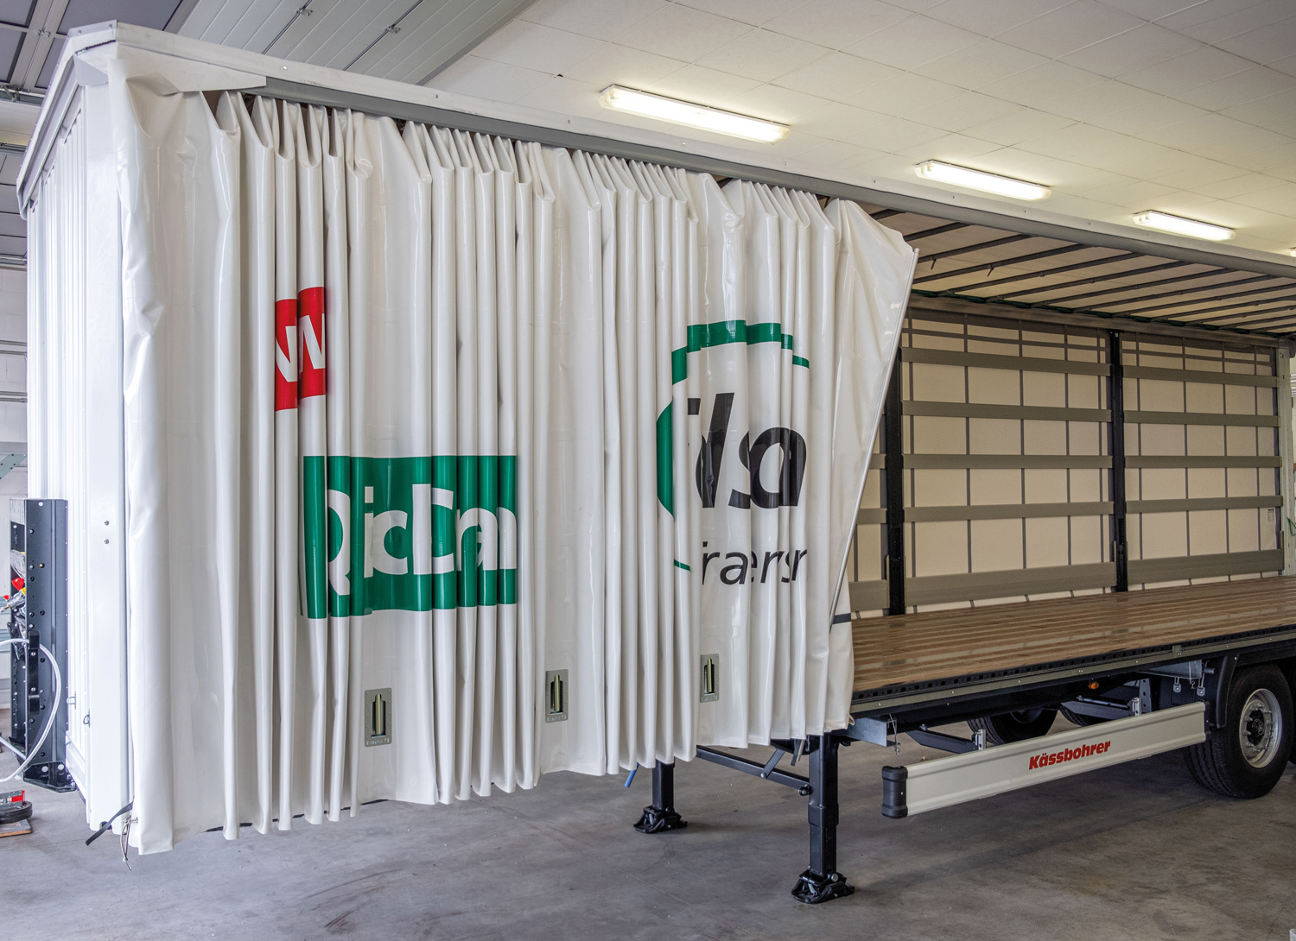 QuickCurtain open

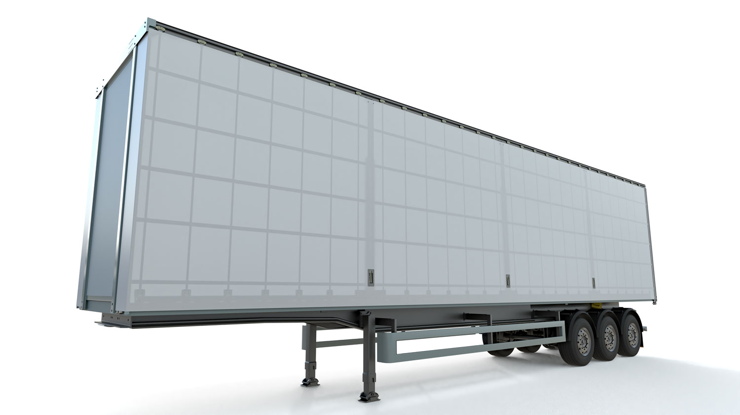 QuickCurtain front

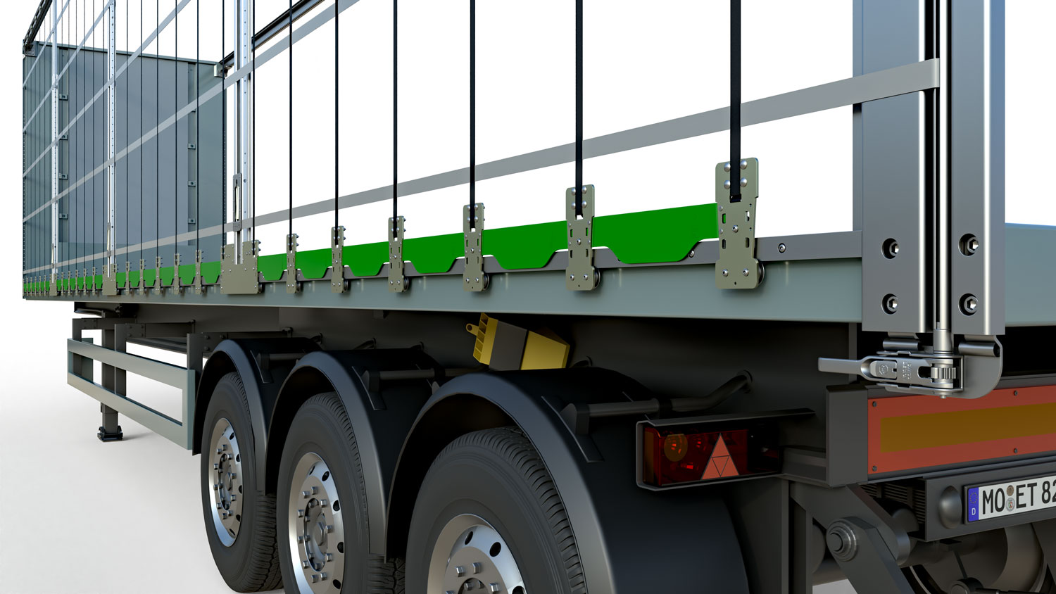 QuickCurtain rear tarpaulin hidden

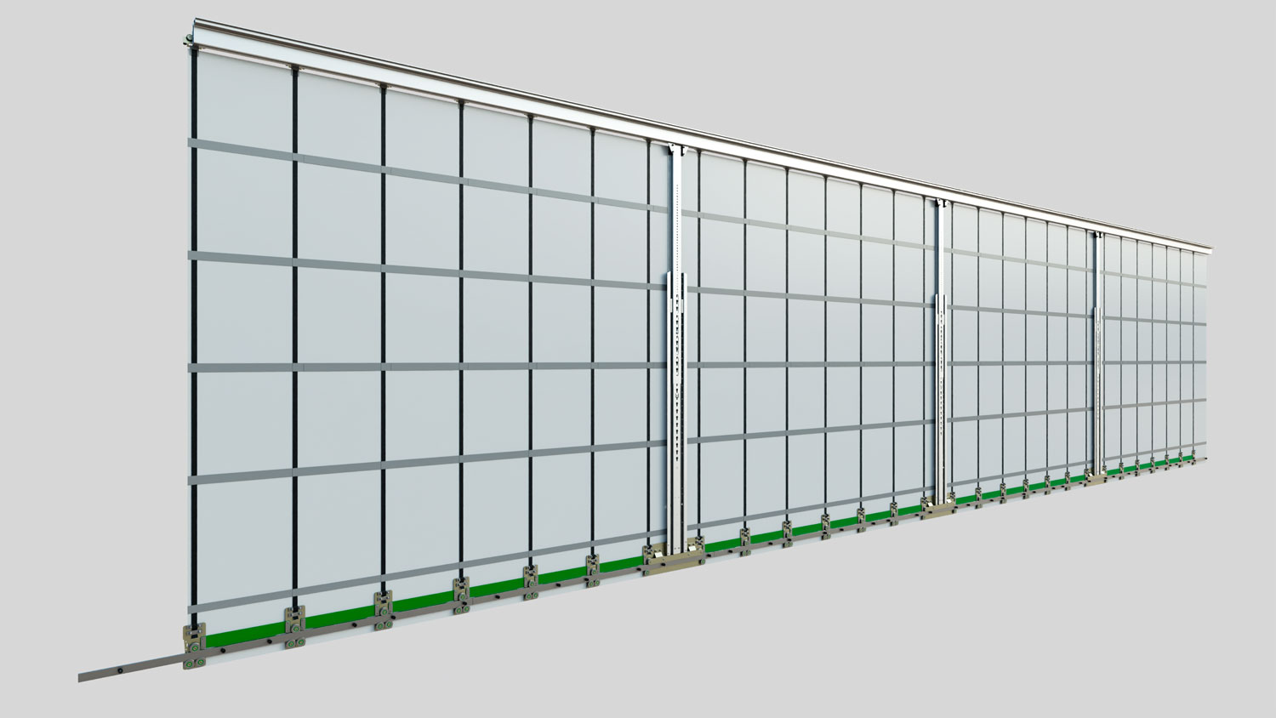 QuickCurtain inside complete

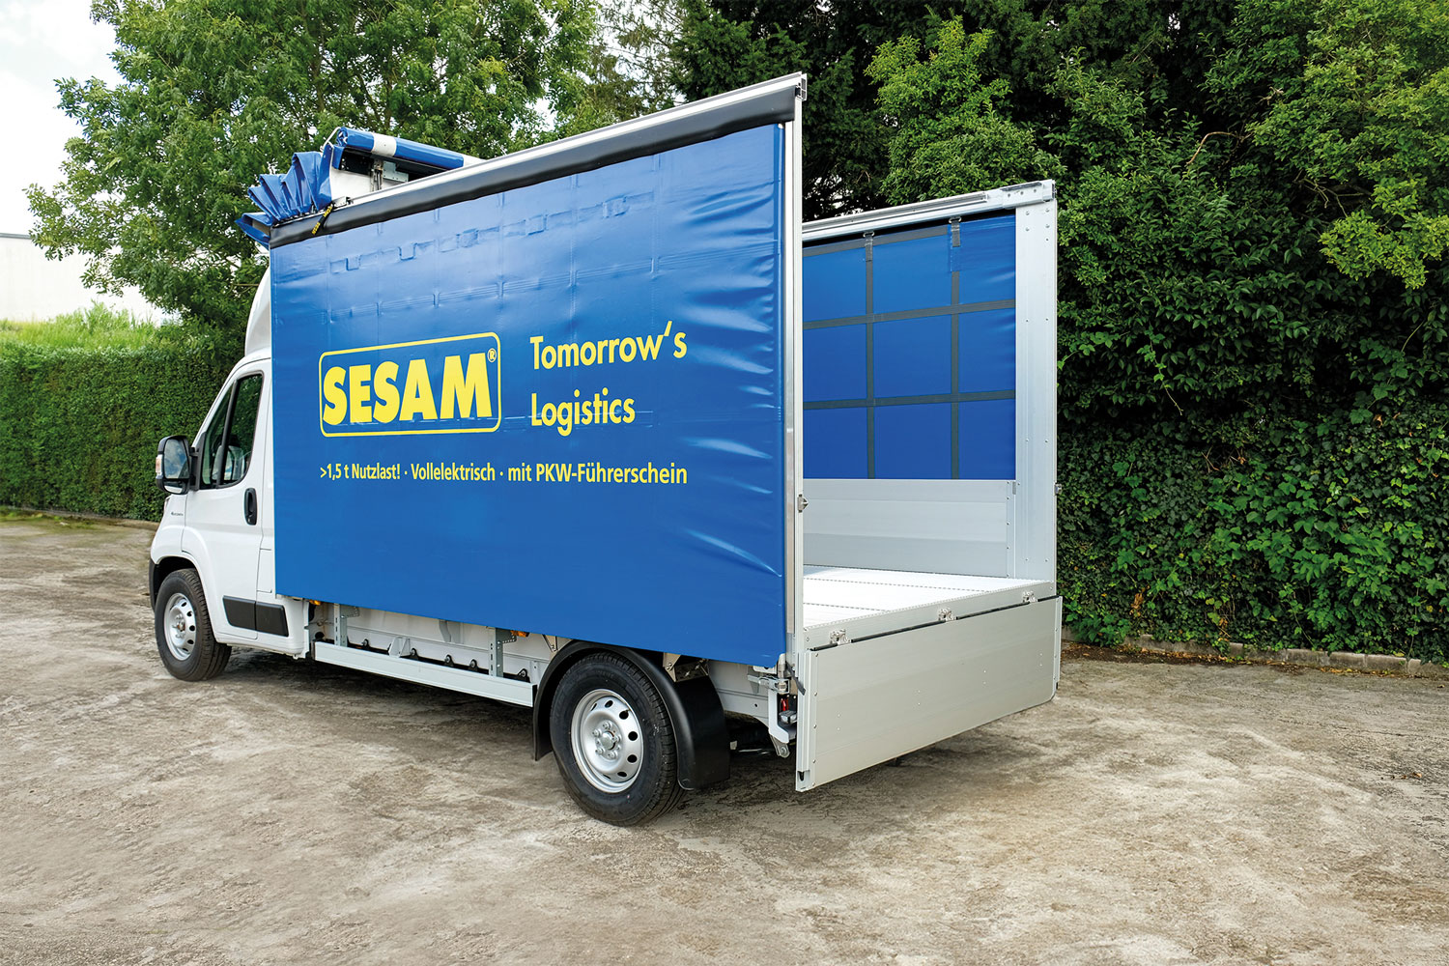 QuickCurtain small transporter

**Contact Edscha Trailer Systems:**

Mr. Roger Remmel

E-Mail: [Marketing@EdschaTS.com](mailto:Marketing@EdschaTS.com)

www.EdschaTS.com Member of VBG GROUP