*  
  
  
Press Release 08/2024*

*Moers in August 2024*

# Press Release

### Edscha Trailer Systems Presents E-Drive at IAA 2024

*Innovative Motorization for Tarp Systems*

**Edscha Trailer Systems, a leading provider of forward-looking sliding tarp systems, is unveiling a new generation of its E-Drive at this year's IAA in Hanover. The new E-Drive will be showcased in a live demonstration featuring the CS-Hybrid tarp type.**

**State-of-the-Art Technology for Maximum Efficiency**

Edscha Trailer Systems' new E-Drive sets new standards in the motorization of sliding tarp systems. Equipped with two control rails and two motors, the E-Drive ensures synchronized operation even under the most demanding conditions. This dual-drive technology delivers precise and consistent movement of the tarp, further enhancing the system's reliability and durability.

Thanks to its low power consumption, facilitated by a standard interface, the E-Drive can be seamlessly integrated into existing vehicle electrical systems without requiring additional fuses. This not only offers logistics companies a cost-effective solution but also the opportunity to optimize their workflow through simple and quick installation.

**Proven Technology Meets Innovation**

Edscha Trailer Systems has a long-standing tradition in the development of drive controls. As early as the 1980s, the company introduced the first drive control for full tarpaulin systems. With the new E-Drive, Edscha TS continues to build on proven technology, refined through continuous innovation. The solution presented at IAA 2024 is the result of extensive research and development and reflects the company’s decades of experience.

**Enhanced Safety and Comfort**

The new E-Drive not only delivers cutting-edge technology but also offers a high level of safety and user comfort. The system can be controlled flexibly via a box on the vehicle, a switch in the driver’s cabin, or an external remote switch. This versatility allows drivers to operate the tarp safely and conveniently, even in challenging situations where leaving the cabin is not possible.

**Visit Us at IAA 2024**

Edscha Trailer Systems warmly invites all interested parties to experience the new E-Drive live at IAA 2024 in Hanover. Visit us in Hall 27, Stand B03, and discover the innovative strength and performance of our latest development. For more information, please visit our website at EdschaTS.com.

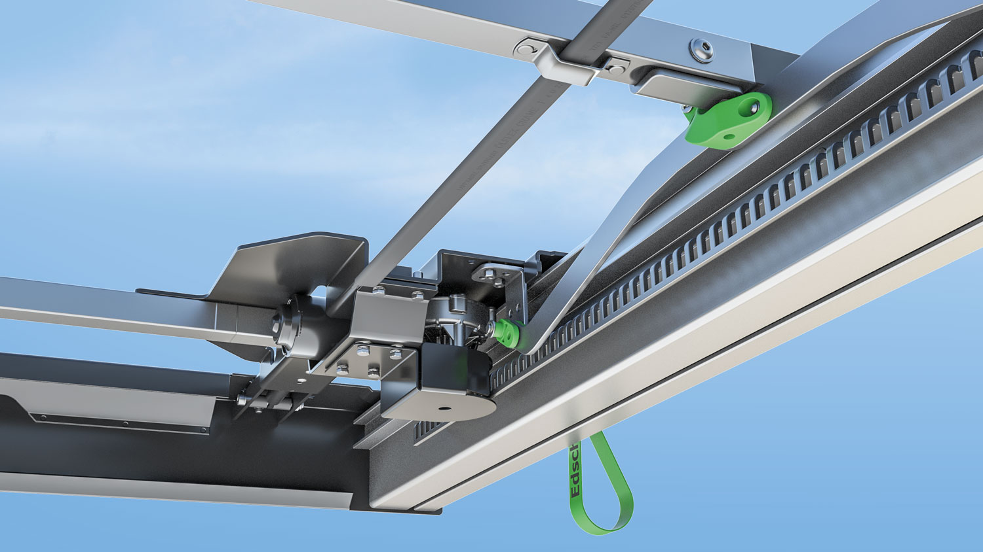 CS-Hybrid E-Drive

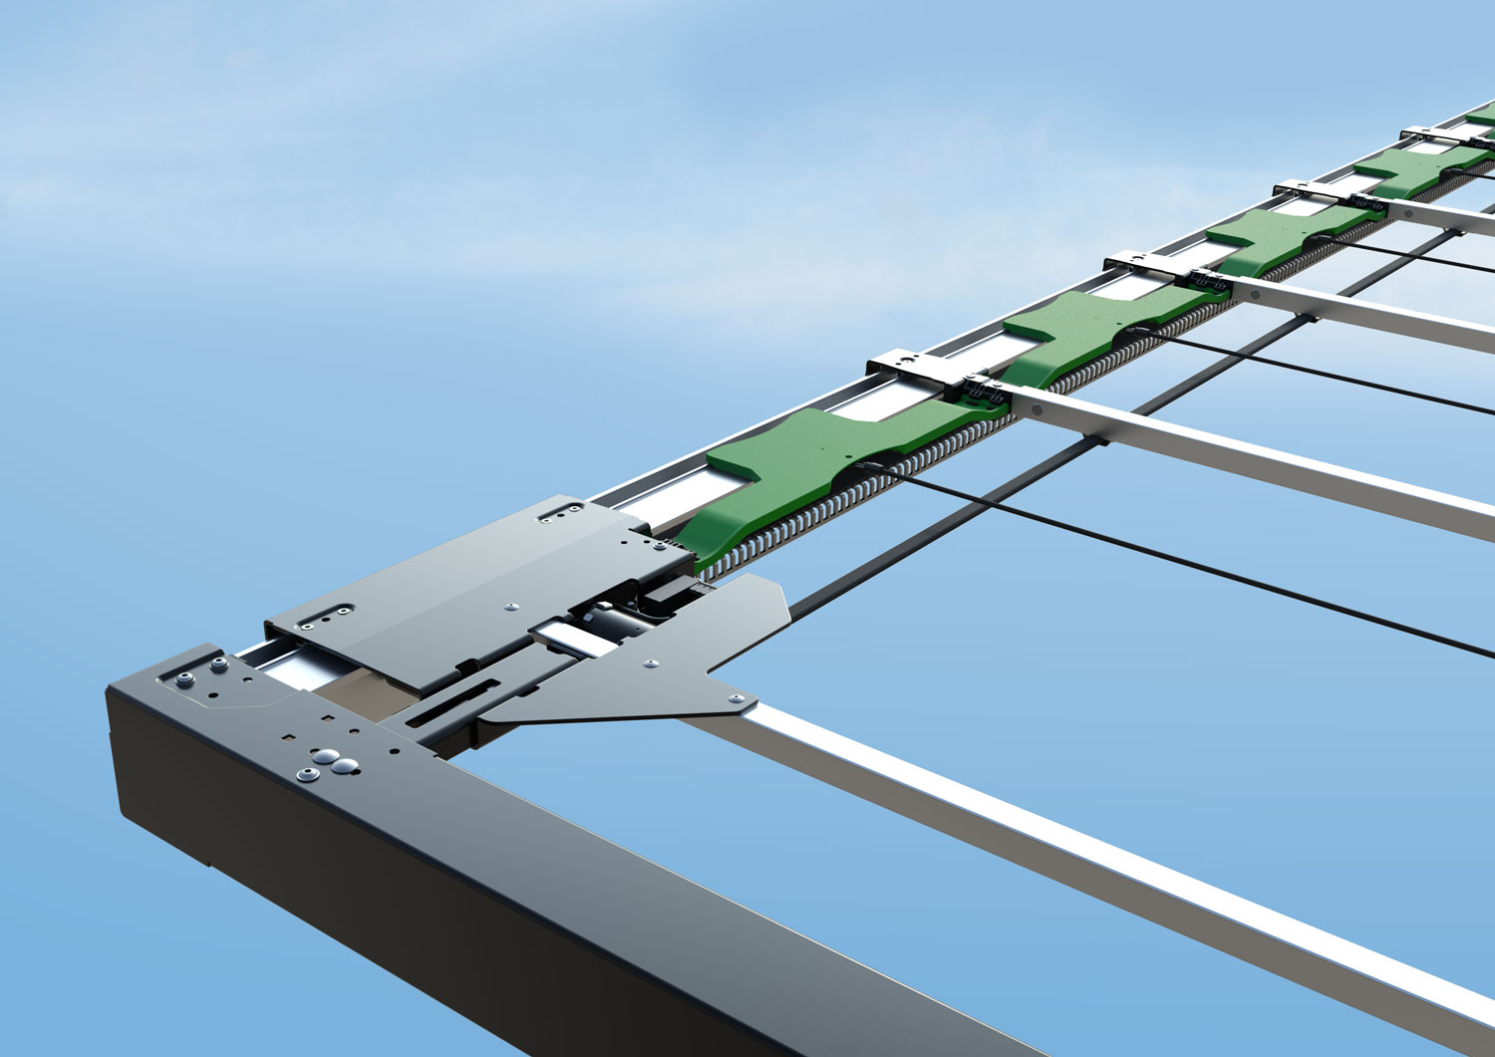 CS-Hybrid E-Drive

 CS-Profi E-Drive

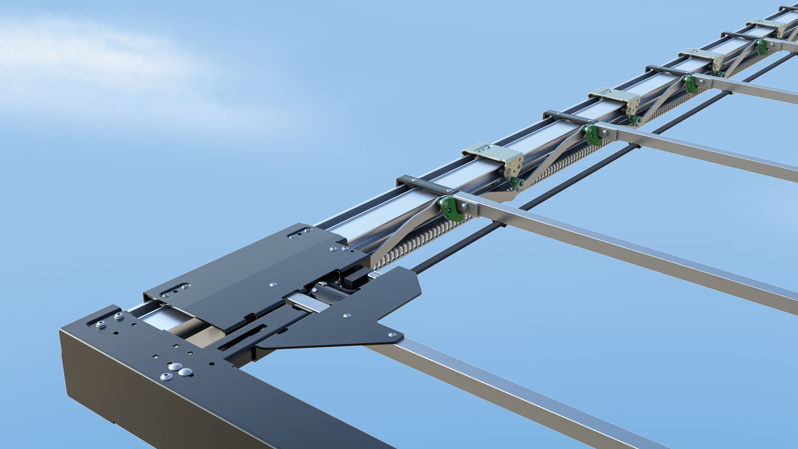 CS-Profi E-Drive

**Contact at Edscha Trailer Systems:**

Mr. Roger Remmel

E-Mail: [Marketing@EdschaTS.com](mailto:Marketing@EdschaTS.com)

www.EdschaTS.com Member of VBG GROUP